

**Internet Programming Laboratory**

**CSE 326**

**Topic: Hotel Management System**

Section: K1615

Subhash (A26)

Brijesh Patel (A27)

J.S.K Nikhil (A28)

**ACKNOWLEDGEMENT**

In performing our assignment, we had to take the help and guideline of some respected persons, who deserve our greatest gratitude. The completion of this assignment gives us much pleasure. We would like to show our gratitude Mr. Dimple Sethi for giving us a good guideline for assignment throughout numerous consultations. We would also like to expand our deepest gratitude to all those who have directly and indirectly guided us in writing this assignment.

Many people, especially our classmates and team members itself, have made valuable comment suggestions on this proposal which gave us an inspiration to improve our assignment. We thank all the people for their help directly and indirectly to complete our assignment.

**DECLARATION**

I am submitting the assignment for:

* A group project on behalf of all members of the group. It is hereby confirmed that the submission is authorized by all the members of the group, and all members of the group are required to sign this declaration.

I/We declare that:

(i)The assignment here submitted is original except for source material explicitly acknowledged;

(ii)The piece of work, or a part of the piece of work has not been submitted for more than one purpose without declaration; and

(iii)The submitted soft copy with details listed in the <Submission Details> is identical to the hard copy which is has been submitted.

I/We also acknowledge that I am/we are aware of the University policy and regulations on honesty in academic work, and of the disciplinary guidelines and procedures applicable to breaches of such policy and regulations, as contained in the University website. (http://lpu.in)

**In the case of a group project, we are aware that each student is responsible and liable to disciplinary actions should there be any plagiarized contents/undeclared multiple submission in the group project, irrespective of whether he/she has signed the declaration and whether he/she has contributed directly or indirectly to the problematic contents.**

It is also understood that assignments without a properly signed declaration by the student concerned and in the case of a group project, by all members of the group concerned, will not be grade by the teachers(s).

_________________________ ____________________

Signatures Date

________________________ ___________________

Names Student IDs

**_____________________ ___________________**

Course code Course title

**Table of Contents**

|  |  |
| --- | --- |
| **S.no** | **Modules** |
| 1 | Homepage |
| 2 | Reservations |
| 3 | Travel agents |
| 4 | Guest Response management |
| 5 | Call accounting |
| 6 | Voice mail |
| 7 | Internet access & billing |
| 8 | Sales & Catering |
| 9 | Spa/Health Club |
| 10 | Feedback & Suggestions |
| 11 | Contact Us |

**Introduction**

The project we have been assigned with is “***Hotel Management System***”. A hotel functions properly only with the help of back-end operations which play a key role. All the back-end operations such as guest response management system, finance, HR, CRM, housekeeping, restaurant, quality management and many more fall under Hotel management system. It covers all the basic and complex functions of the hotel.

Hotel management system lets the hotel staff to understand the key needs of the guest just to serve better and make them feel good to be ahead in the growing competition in the current world scenario. It plays a crucial role to keep the hotel reserved.

The website we have designed consists of a simple interface that enables the user of the website to feel familiar with the interface so he feels it easy to use.

As a part of this project we tried to represent the website that is used in hotels for their convenience to provide the guests with the best stay experience by knowing their priorities and preferred luxuries.

**Module-wise Description**

In this website, we created a home page which consists of different links through navigation panel and description of each module is given in the link and the process are given too. It also consists of description and information about who we are and where do we stand.

The reservations tab in the navigation panel consists of the table and room reservations which are offline and online which need some basic details of the guest for booking. The travel agent’s webpage consists of the different touring options which guests can use for their convenience. The guest response management system is a unique tool which allows users to specify their favourites which provides the hotel authority to improve the quality of their stay.

Call accounting and voice mail is a special privilege for users that can be used as per their need to access their confidential or personal voice mails and calls which specify the duration of their calls which ease the confusion of bill payments.

Internet is one of the most vital need of man today. The customers can access the endless powerful WIFI by just logging into the internet access & billing which are provided to them while registration for the room stay.

Sales & catering webpage is for those who want to order food for special occasions and functions. This webpage consists of different forms for table reservation, catering order, and more for convenience of the customers.

Spa and Health club in hotels is necessary because most of the people want to rejuvenate themselves after some hectic schedule. So, people visit them in regular intervals. Providing membership cards would attract more people which might be beneficial for hotels. So, database management is very essential to maintain the card and renewal details of the customer. This is made easy by providing simple interface to the staff of the hotel to manage guest details.

Feedback and suggestions webpage is necessary for hotels just to know how they stand in the world of reality and to improve themselves to serve their customers the best. This webpage consists of a small survey with questions for the customer to answer. Contact Us webpage is for those who want to know more about the hotel which consists of different modes of communications giving the customer number of options to choose from.

**Objective**

We have created this website to provide convenience to the users and customers in booking or reserving the tables and rooms. The website is a simple interface with which users can reserve rooms with ease. The main objective behind creating this website is to acknowledge the real problems in creating a website.

Hotel management system is the key role in all of the hotels to operate successfully and in a proper manner. We created this website to provide a hustle free stay to our customers by filling some basic details of themselves. It the basic HTML and JS so as to perform this task effectively.

With this basic website hotel authorities can manage basic queries and complaints from their customers and serve them with better care. They can take the feedback positively by finding the fields they are lagging in and improving themselves in those particular fields to help their hotel in advancement of serving.

**Methodology**

**Flowchart depicting the internal structure of the website.**

**Homepage**

Table Reservation

Room Reservation

Description

Travel Agents

Contact us

Database Form

Login

Existing User Form

New User Form

Table

Events

Tour Form

Reservations

Display

Login

Login

Guest Response

Sales & catering

Spa/Health Club

Internet Access

Feedback & Suggestions

Voice Mail

Call Accounting

**Screenshots of the website**

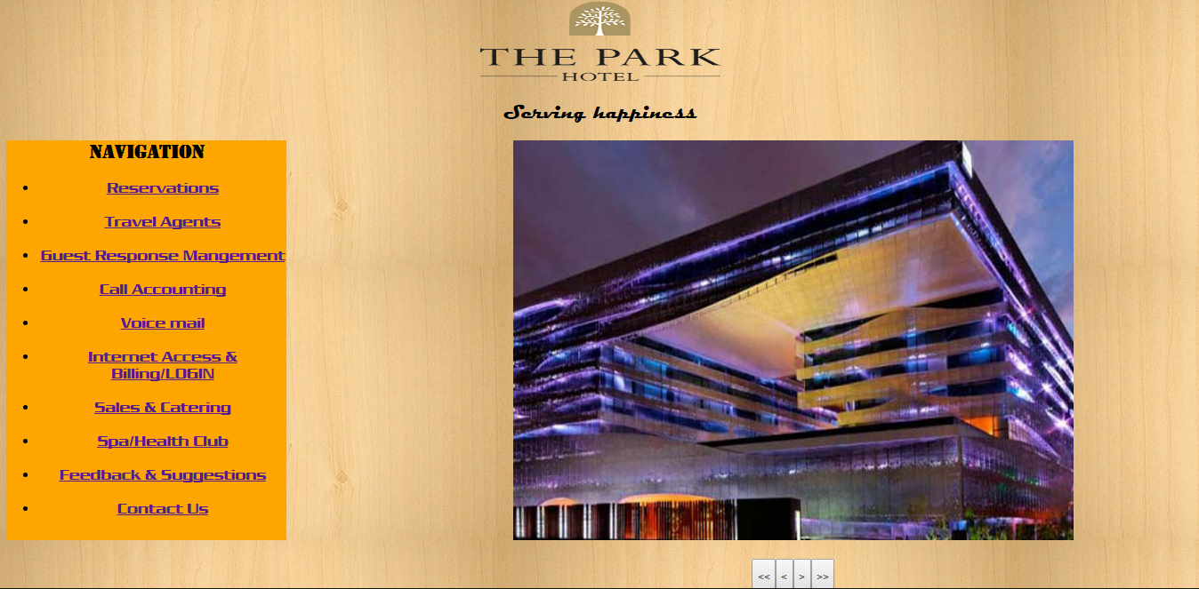

Snapshot showing homepage with navigation panel included on the left side of the screen

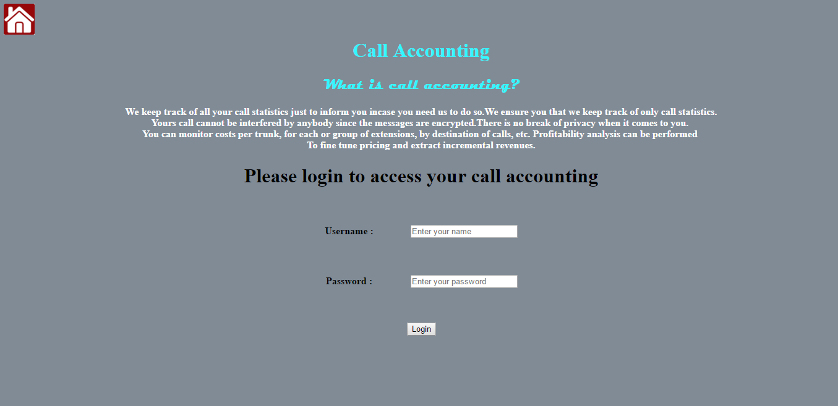

Snapshot showing call accounting

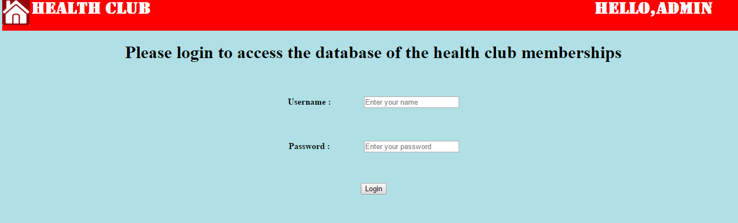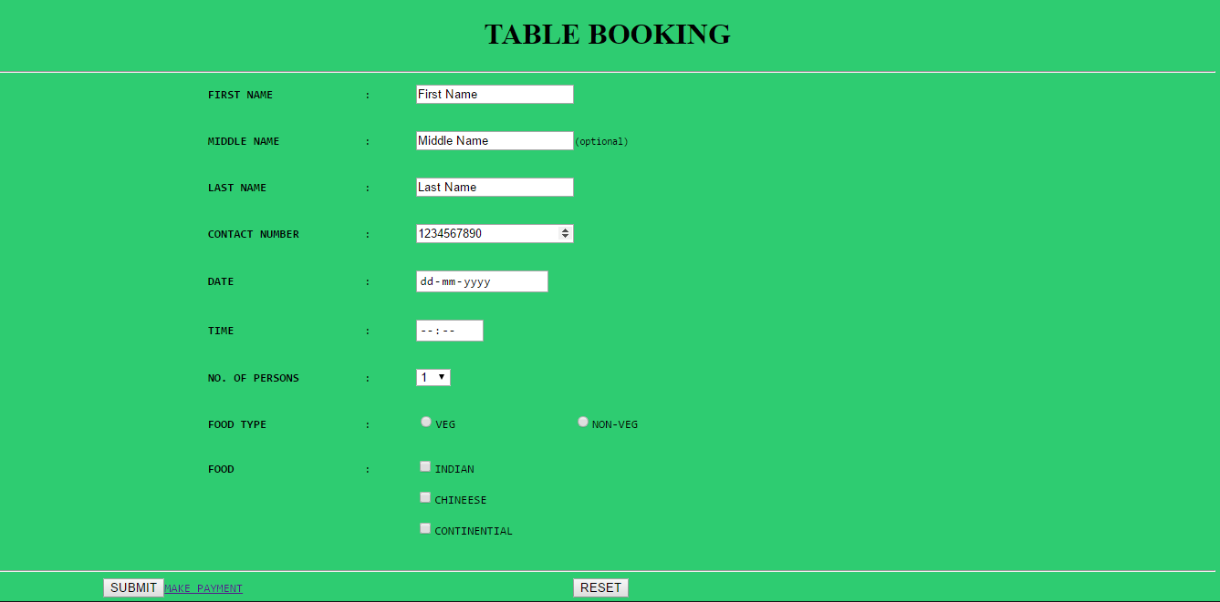

Login interface for hotel authorities for editing the database of health club

Snapshot showing the reservation for table

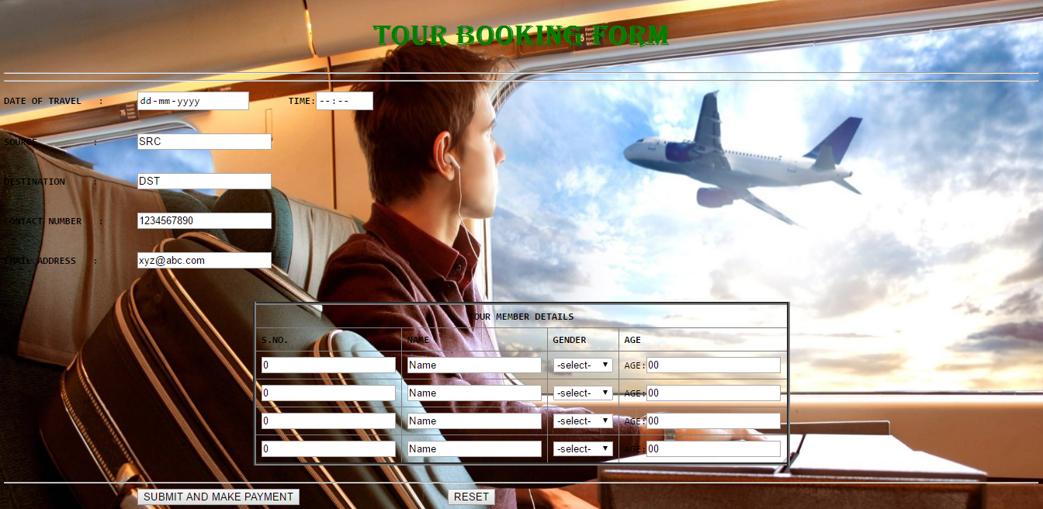

Snapshot showing tour booking form

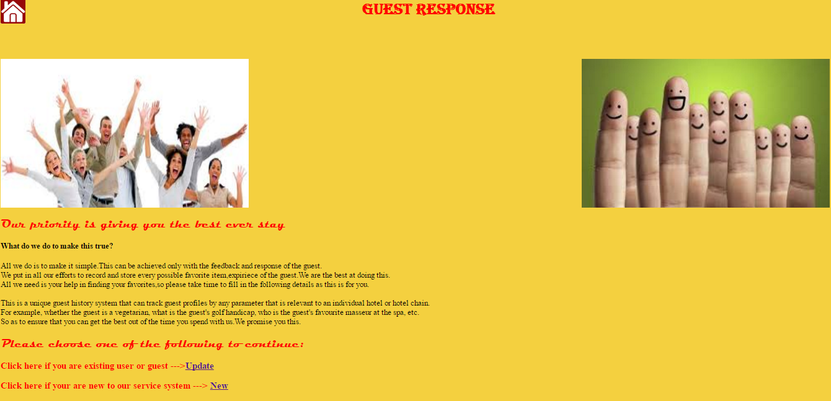

Snapshot showing guest response management system

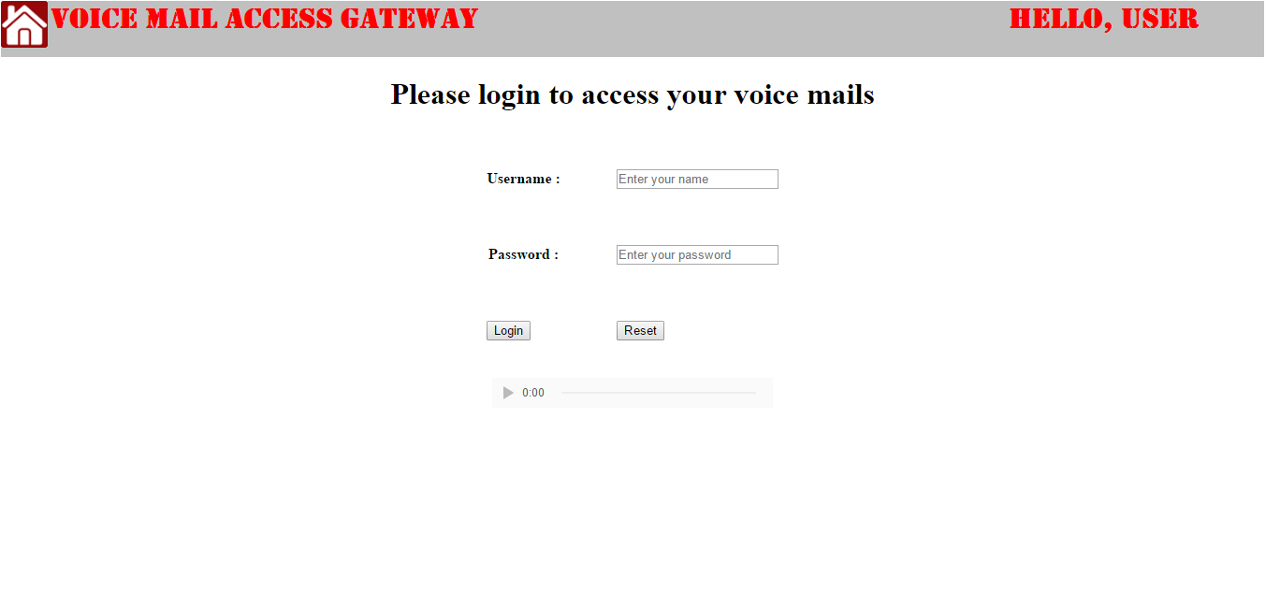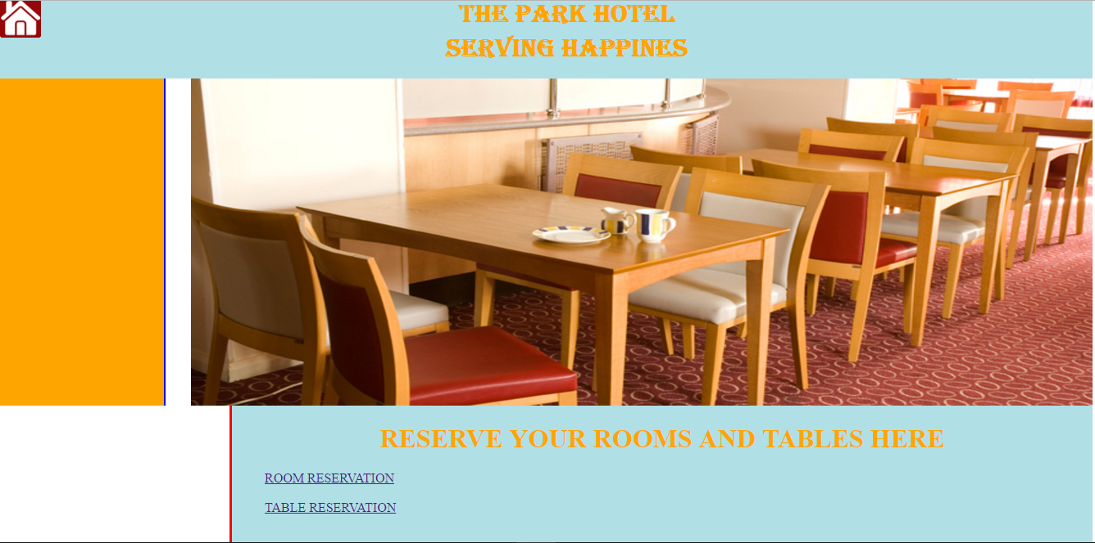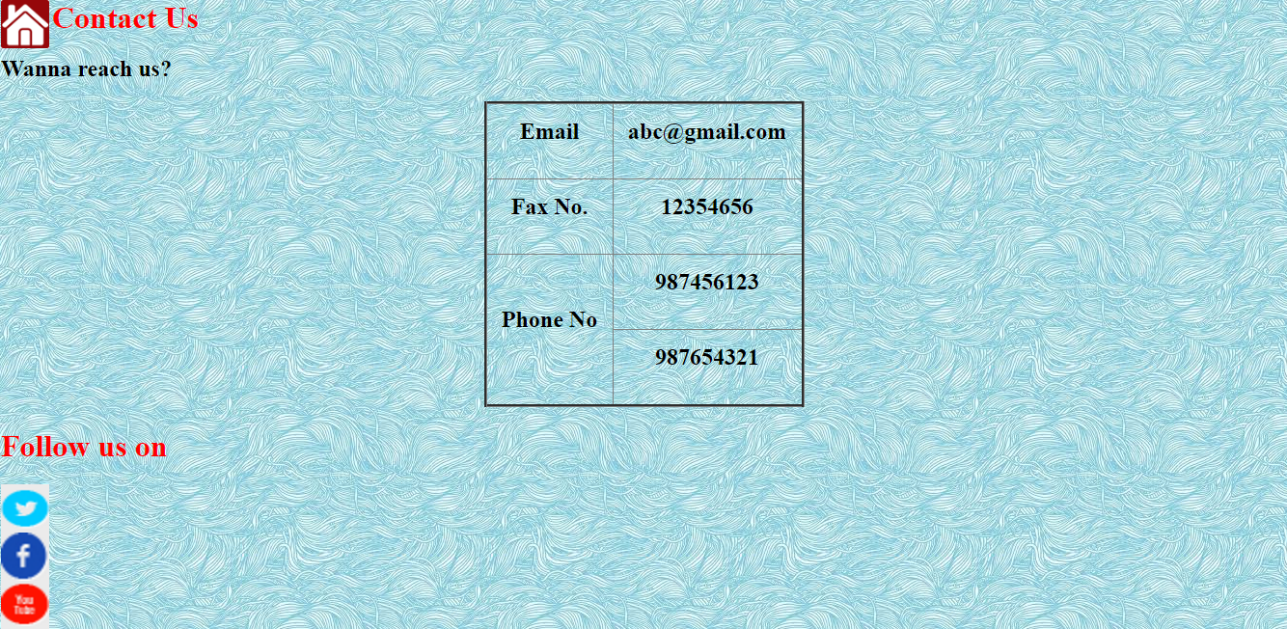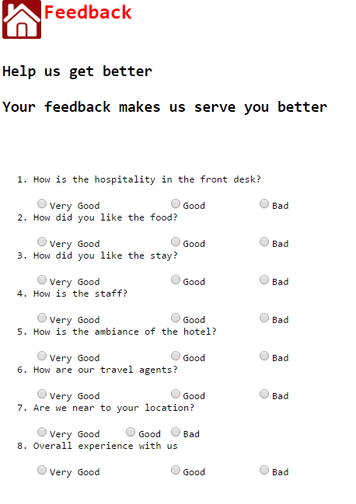

Snapshot showing voice mail access gateway login webpage

Snapshot showing the home page for reservations

Screenshot showing contact us page

Snapshot showing feedback page of the webpage

**References**

1.Google images (https://www.google.com/imghp?gws_rd=ssl)

2. https://hospitalitytechnology.wordpress.com/2012/05/07/what-is-hotel-management-system/